**ArchiMate Business Layer Notations**

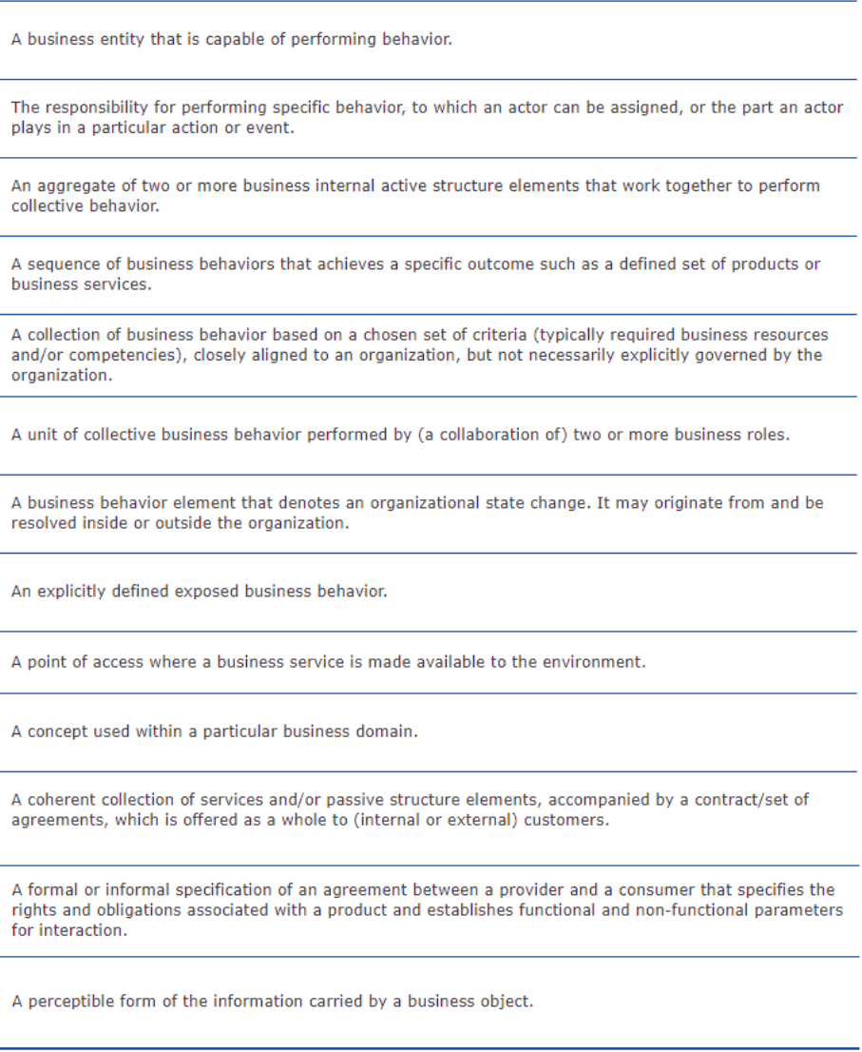

1

2

3

4

5

6

7

8

9

10

11

12

13

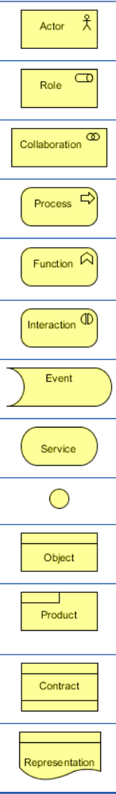

7

8

9

10

11

12

13

6

5

4

2

1

3























**ArchiMate Application Layer Notations**

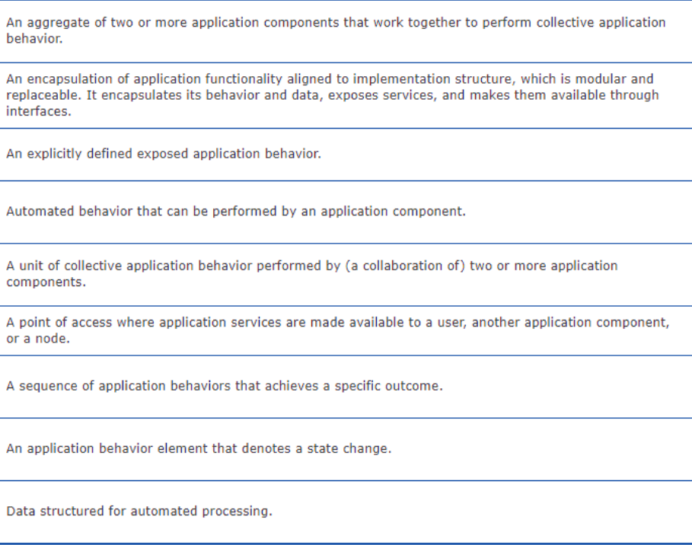

9

8

7

6

5

4

3

2

1

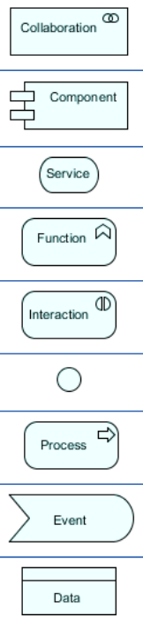

1

9

8

7

6

5

4

3

2















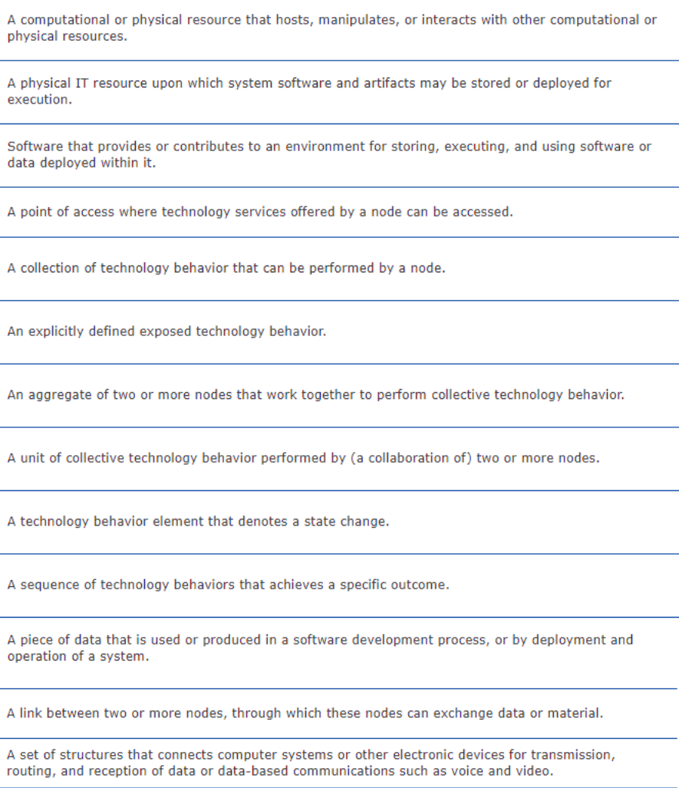**ArchiMate Technology Layer Notations**

13

12

11

10

9

8

7

6

5

4

3

2

1

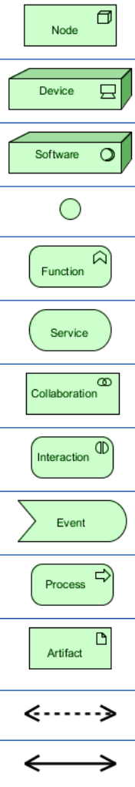

13

12

11

10

9

8

7

6

5

4

3

2

1



















**ArchiMate Physical Elements' Notations**

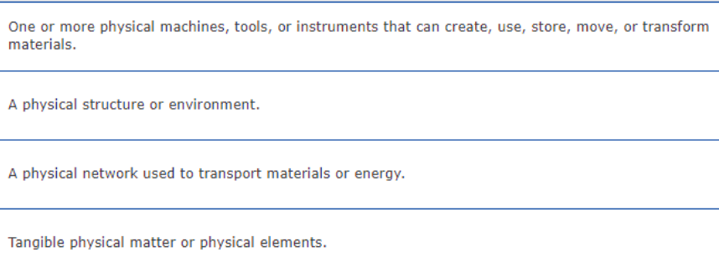

1

2

3

4

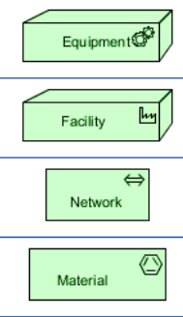

1



2



3



4

**ArchiMate Strategy Elements' Notations**

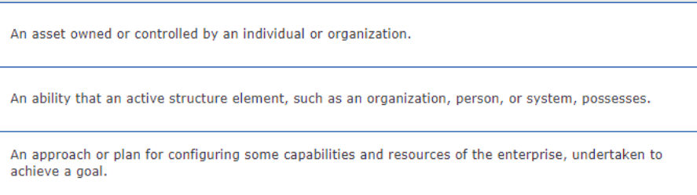

1

2

3

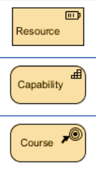

1



2



3

**ArchiMate Implementation and Migration Elements' Notations**

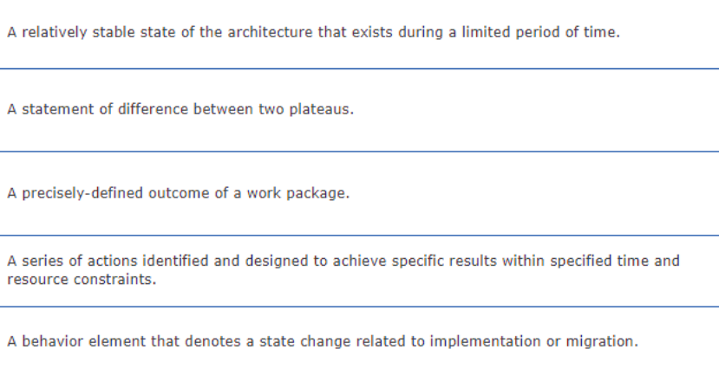

1

2

3

4

5

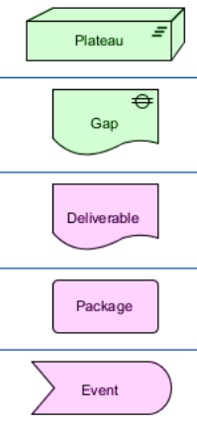

1



2



3



4



5

**ArchiMate Motivation Elements' Notations**

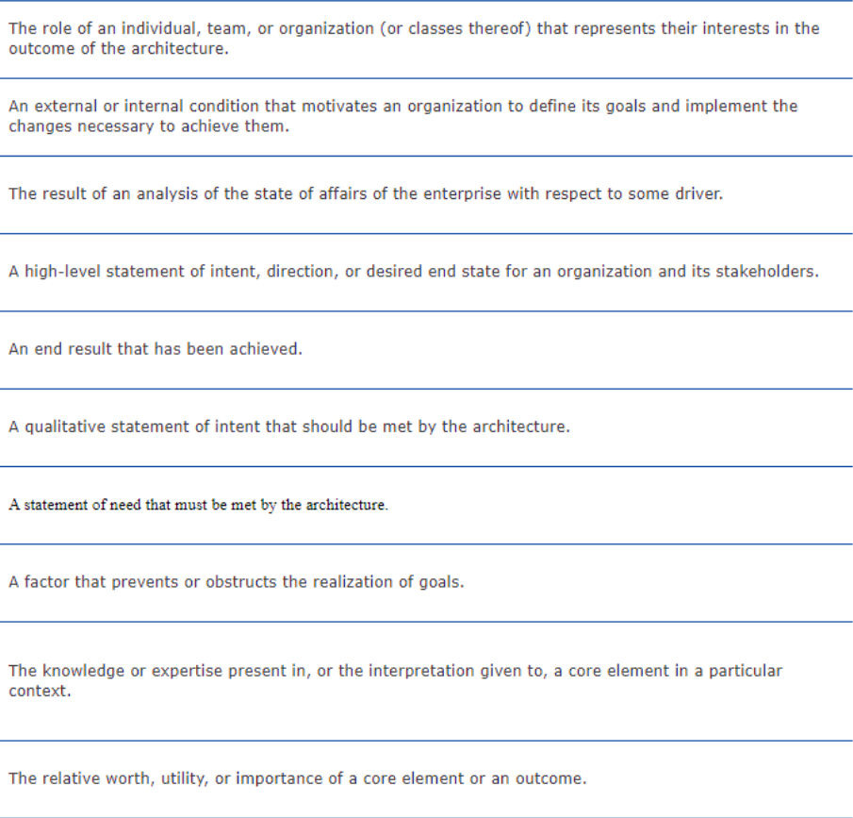

1

2

3

4

5

6

7

8

9

10

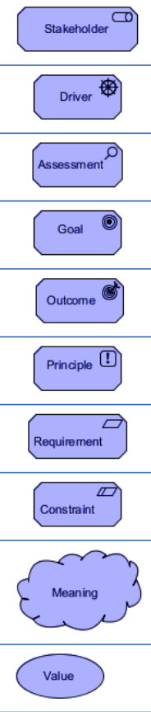

1



2



3



4



5



6



7



8

9





10

**ArchiMate Relationship Summary**

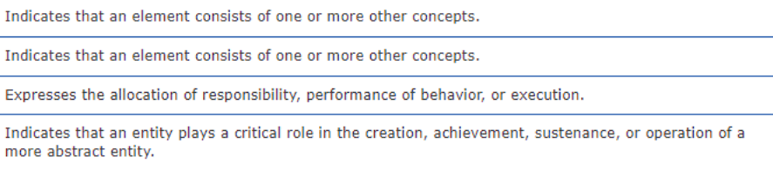

1

2

3

4

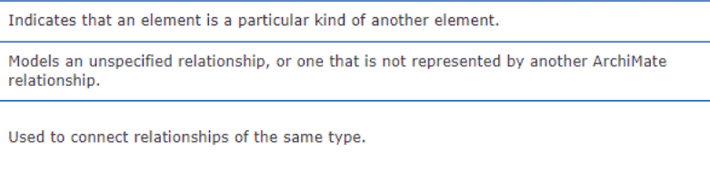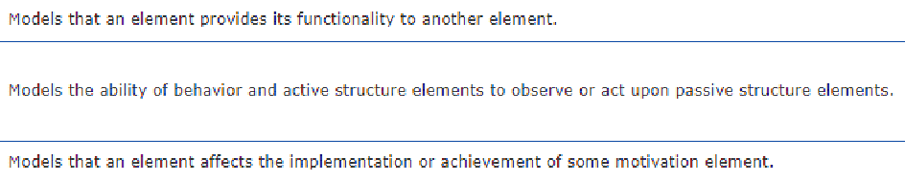

5

6

7

8

9

10



11

12

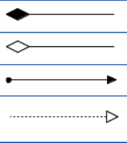

1

2

3

4

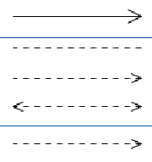

5

6

7

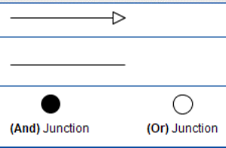

8

9

10



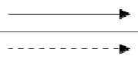

11

12